Web Workers

**What are Web Workers?**

Web workers are used for running any script in the background threads, without interfering with the user’s interface. So if you have heavy computations on your user side, you can use web workers to do the heavy tasks while allowing the browser to give your users a smooth and better experience.

Create a new Angular application using below command –

ng new web-worker-demo

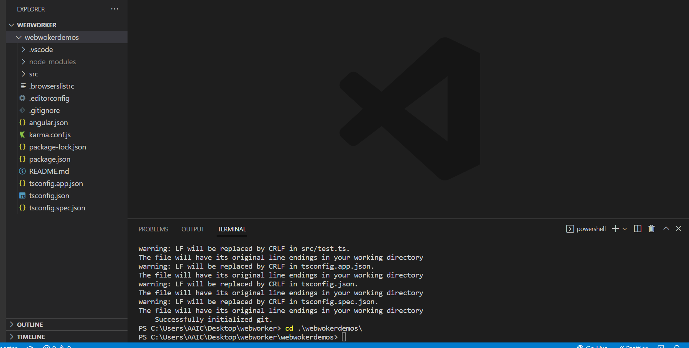

Add new web worker using below command –

ng generate web-worker app

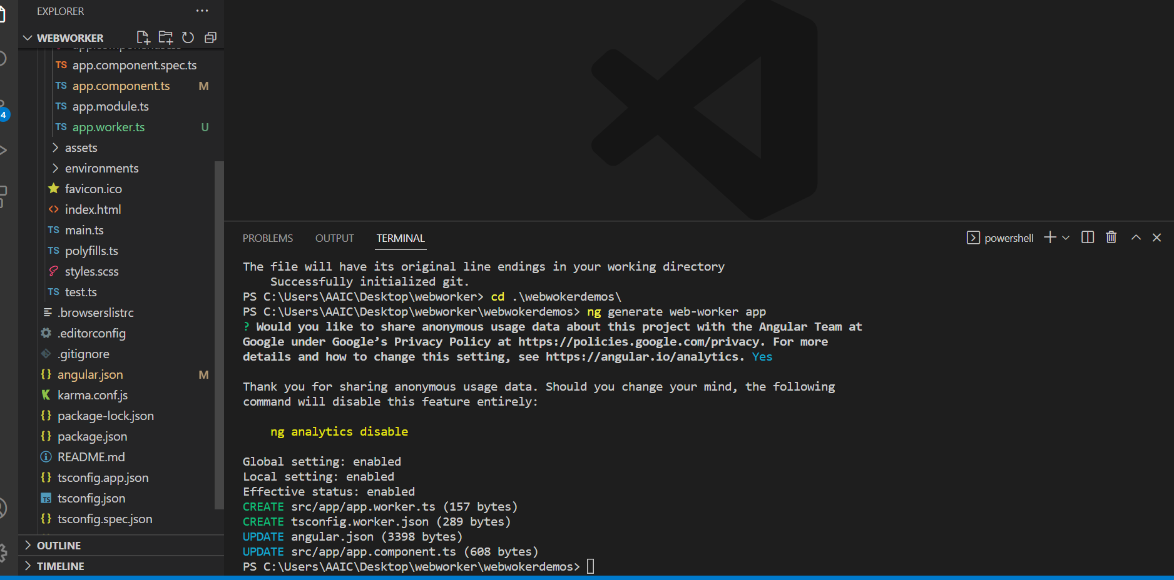

This command will do the following:

1.Creates a new file tsconfig.worker.json. This file looks as below.

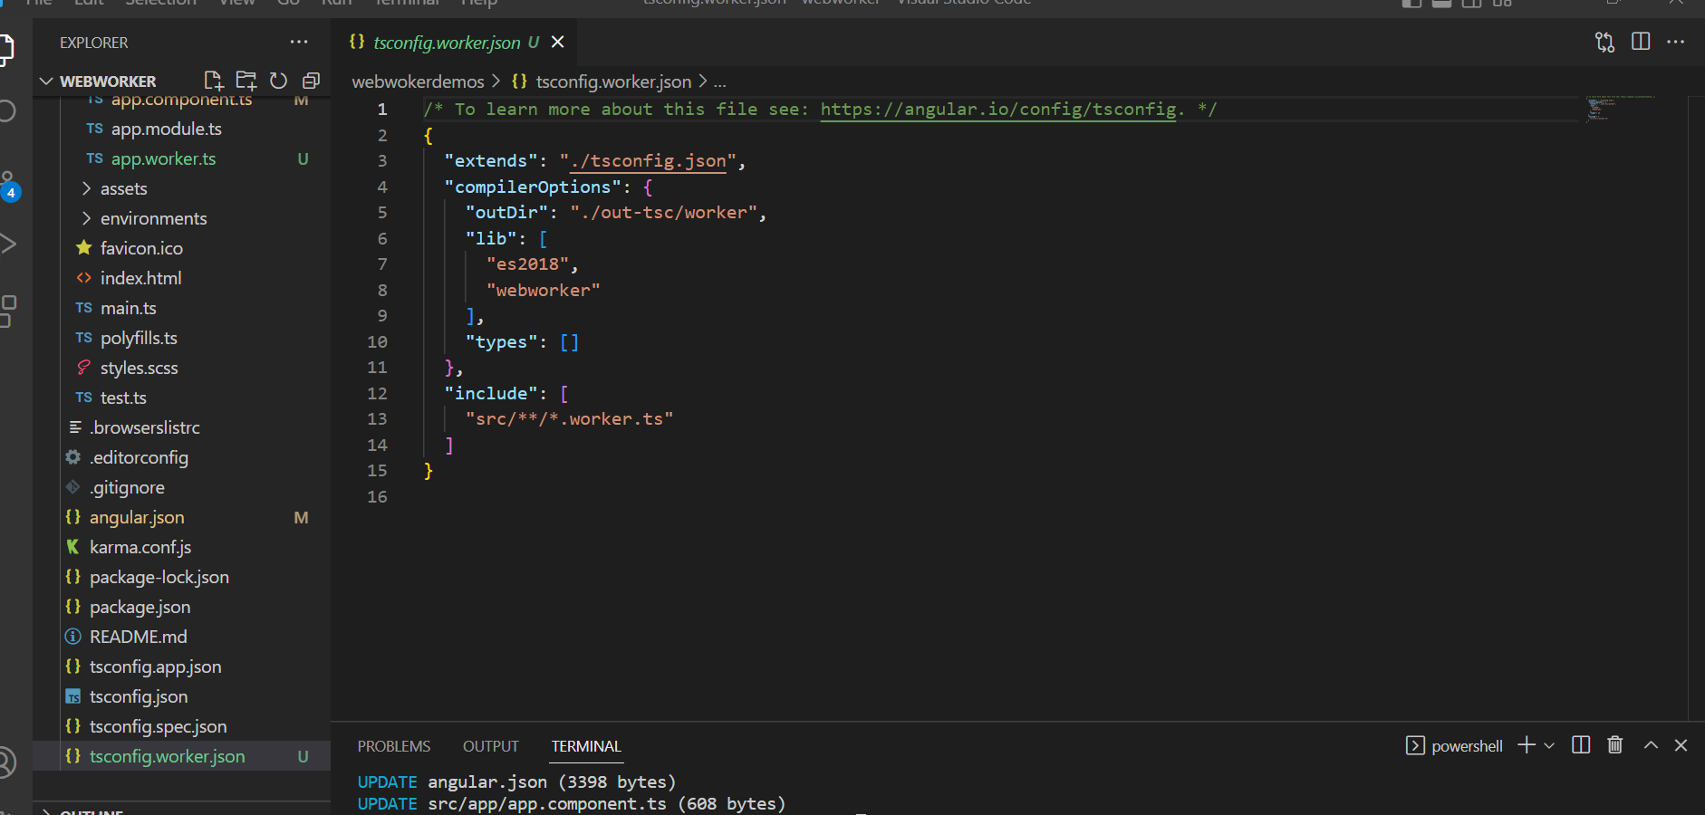

2. Creates app.worker.ts and this is where you get the response from the worker.

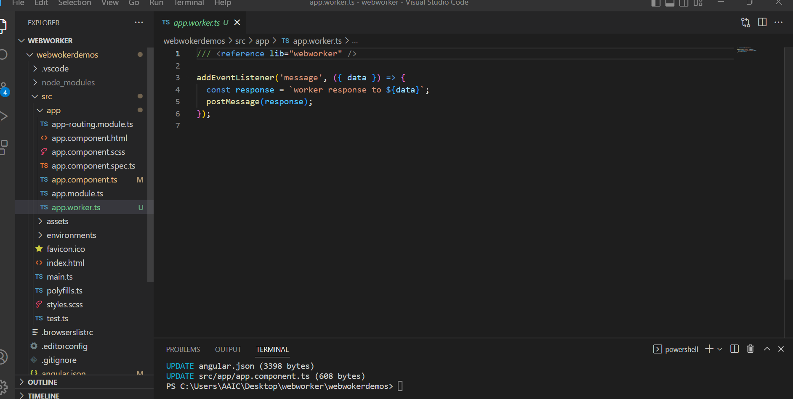

3. In angular.json,

adds ”webWorkerTsConfig”:“tsconfig.worker.json” in build > options and registers the generated tsconfig file for the web worker.

 Your app.component.ts will also be modified and the worker will be used here.

